Pertemuan 5

Autoload.php





**PhpMyAdmin**

Tabel user

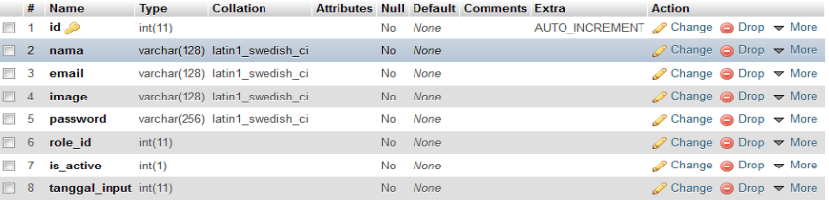

Table role



Field role

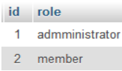

Table kategori



Field kategori

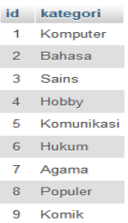

Table buku

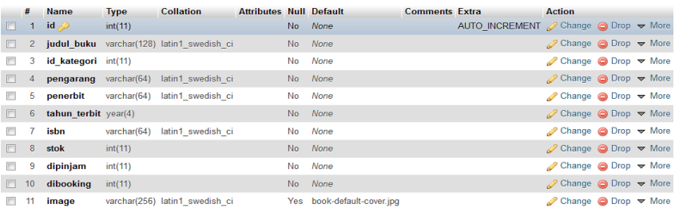

Field buku

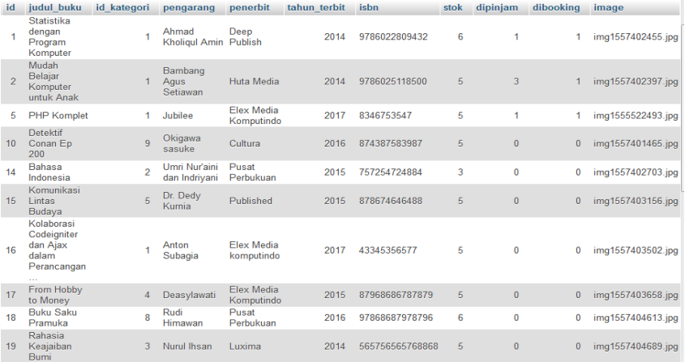

Application/config/Database.php

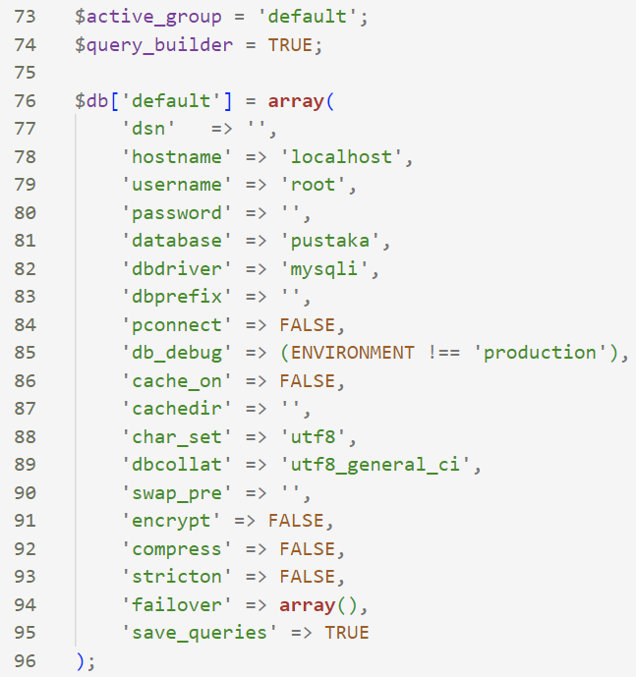

Application/ models/ ModelUser.php

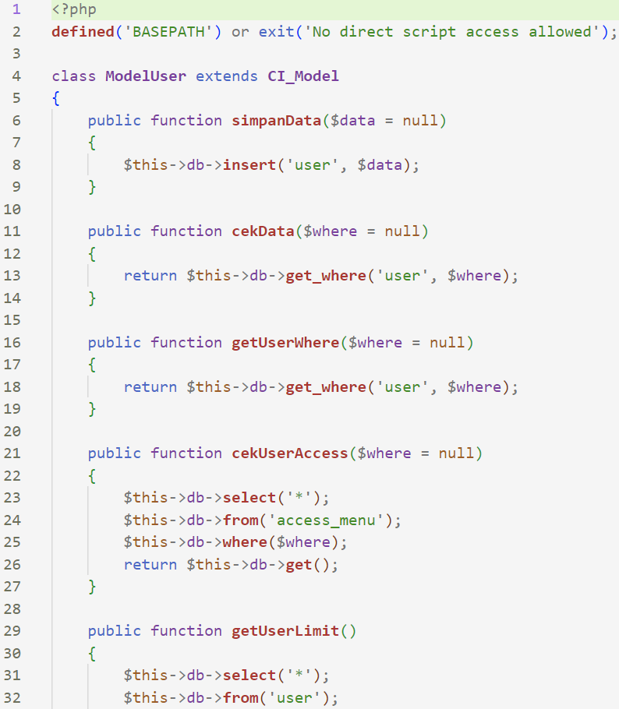

Application/ models/ ModelBuku.php

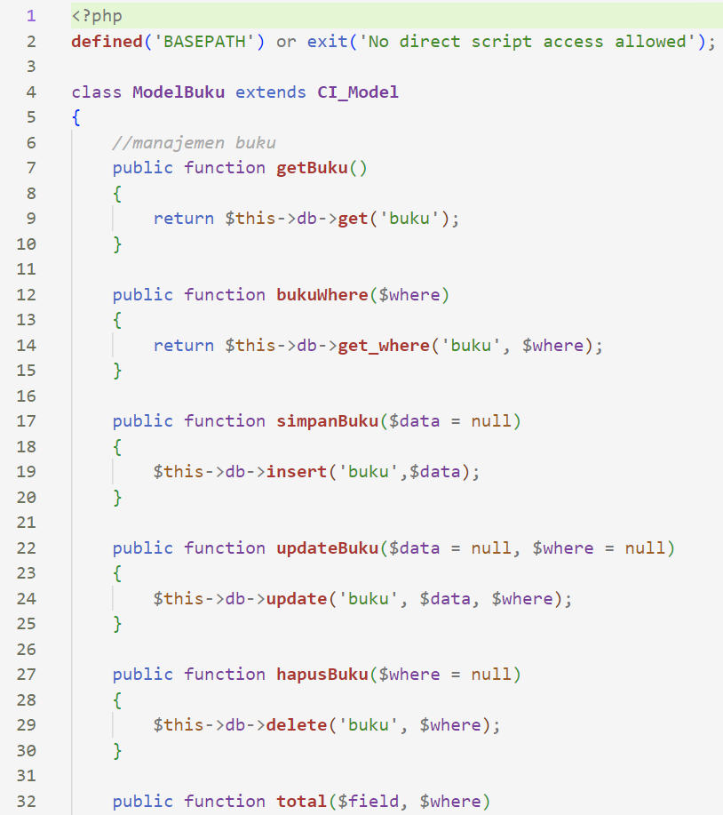

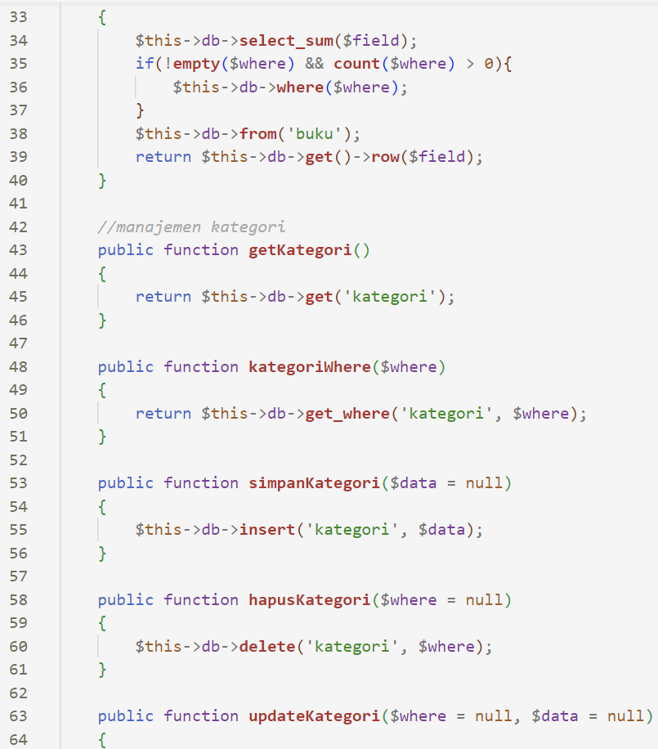

Application/config/autoload.php

